**Officer Name**

Officer Title & Employee ID

[Officer.Name@wellstar.org](mailto:Officer.Name@wellstar.org) (123)456-7890

**Hiring Leader Name**

Hiring Leader Title & Email

Key Contact Info for hiring leader & support person

**Direct Leader (DL)**

The hiring leader owns the onboarding process to ensure the new hire has the time, support, and resources to be successful from day one. It is critical that the hiring leader blocks time to ensure the new officer can focus on onboarding before assuming operational responsibilities.

**Action:** Refer to Strategic Onboarding Plan (p.2) and Detailed Onboarding Schedule.

**Pre-Hire**: Complete Detailed Onboarding Schedule & share with New Hire.

**Day 2**: Review Onboarding Plan and Schedule with New Hire

**Week 1:** Build the foundation for Success by acclimating New Hire to Wellstar culture and team members.

**Week 2:** Schedule meetings w/ key stakeholders, and review updates and plans on key projects.

**30 Days:** Support New Hire to accelerate learning and develop relationships.

**60 Days:** Help New Hire identify quick wins.

**90 Days:** Support the New Hire’s understanding of strategic plan and how to align business initiatives and culture.

**HR Leader (HR)**

The HR leader regularly checks in with the new officer to ensure executive assimilation is successful and provides background on the team and key talent strengths/opportunities. HR leader also briefs new officer on history of trust.

**Action:** Refer to Strategic Onboarding Plan and Detailed Onboarding Schedule.

**Pre-Hire**: Partner with Hiring Leader to complete Onboarding Plan.

**Week 1:** Meet and Greet with New Hire.

**30:** Prepare for Team Acclimation (p. 5-6)

**60:** Review key talent metrics and onboarding check in.

**90:** Support the creation and implementation of People Strategy for new officer’s function and check in.

**New Hire (NH)**

Your first 90 days is focused on assimilation with the new role, team, and Wellstar. Our goal is to help you learn about Wellstar’s culture and prepare you to be successful and productive. This is about you, so ask questions, dive in, and let us know what you need.

**Action:** Review Strategic Onboarding Plan and Detailed Onboarding Schedule.

**Day 2**: Review Onboarding Plan and your Detailed Onboarding Schedule with your Leader

**Week 1:** Orientation

**30:** Learn and Assess – learn about Wellstar’s strategy, systems, and processes.

**60:** Demonstrate Insight – what have you seen, what needs to change, identify opportunities for improvement

**90:** Ownership & Action – take action and make an impact.

**Support Person (SP)**

The Support Person helps schedule key “Meet and Greet” meetings and coordinates and tracks essential Wellstar technology, resources, and system access. They serve as a connector for key administrative questions and ensuring the new officer has necessary supplies and resources.

**Action:** Review Page 3 to ensure new hire has resources needed.

**Roles and Responsibilities**

Our Mission

To enhance the health and well-being of every person we serve.

Our Vision

Deliver world-class healthcare to every person, every time.

Our Values

We serve with compassion.

We pursue excellence.

We honor every voice.







**Strategic Onboarding Plan**

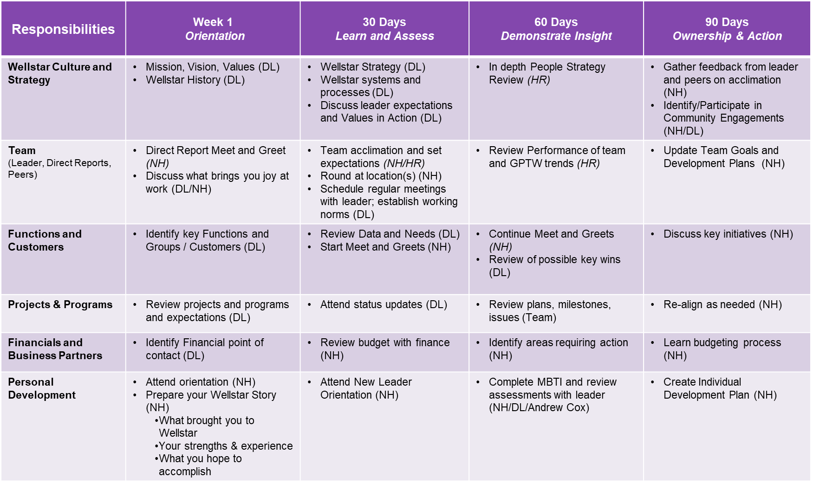

Direct Leader (DL), New Hire (NH), HR Leader (HR)

**Hiring Leader Name**

Hiring Leader Title & Email

Key Contact Info for hiring leader & support person

**Officer Name**

Officer Title & Employee ID

[Officer.Name@wellstar.org](mailto:Officer.Name@wellstar.org) (123)456-7890

New officers should get to know critical stakeholders, who they are, what they and their function do, and how the new hire will interact with that function. Below are a few key areas. Refer to your **Detailed Onboarding Schedule** to determine when you might meet with each function.

* Department / Function Introductions
* Operational Leaders / Direct Reports
* Physician Partners
* Data Analytics
* Compliance (system & site)
* Legal (System)
* Finance (System & Site)
* Marketing
* Purchasing
* HR
* Talent Management / Organizational Learning

Set up for logistics and tactics:

* Employee ID
* Workspace and keys
* Computer
* Cell Phone
* Business Cards
* VPN Access
* Relevant System Access
  + Lawson
  + Strata
  + SuccessFactors
  + Dashboards (Distribution Lists)
* Access to Shared Drives & SharePoint
  + Etc...
* Facility Tour
* Conference Room Locations
* Local contacts, Security, EVS, etc.
* Printing
* Mailbox
* Office supplies
* Brand Resource Center
* New Leader Orientation (NLO)
* Shared Drives

**Key Meetings to Schedule**

**The Essentials Checklist**

**Important Contacts**

|  |  |
| --- | --- |
| Leader | |
| First Last | Title, Contact Information |
| Direct Reports | |
| First Last | Title, Contact Information |
| First Last | Title, Contact Information |
| First Last | Title, Contact Information |
| First Last | Title, Contact Information |
| Colleagues | |
| First Last | Title, Contact Information |
| First Last | Title, Contact Information |
| First Last | Title, Contact Information |
| First Last | Title, Contact Information |
| Support Resources | |
| IT Service Desk | 470-956-6000 |
| Local Security | 470-956-XXXX |
| Your HR Contacts | |
| Your HR VP | Contact Information |
| Benefits | Contact Information |

**Detailed Onboarding Schedule**

**New Hire Goals**

* Connect and build trust with your team
* Learn the organization and build partnerships with your colleagues and stakeholders
* Assess the business and develop plans to maintain or improve performance

|  |  |
| --- | --- |
| **Week** | **Meetings** |
| Week 1  X/XX - X/XX | Day 1: New Employee Orientation  Day 2:  Day 3:  Day 4:  Day 5: |
| Week 2-4  X/XX - X/XX | Check-in with Direct Leader  **30-Day Check-in with Leader** |
| Week 5-8  X/XX - X/XX | Internal Stakeholder Meetings  **60-Day Check-in with Leader** |
| Weeks 9-12  X/XX - X/XX | Internal Stakeholder Meetings:  **90-Day Check-in with Leader** |

**Key Stakeholders**

|  |  |  |  |
| --- | --- | --- | --- |
| **Leader** | **Title** | **Status** | **Notes** |
| Andrew Cox | Chief of Staff & VP of Executive Development | Not Started | Partner on Wellstar Culture and Executive Development |
|  |  |  |  |
|  |  |  |  |
|  |  |  |  |

**Facilities to Round on**

|  |  |
| --- | --- |
| **Top Priority** | **Additional Facilities** |
| Facility 1, Location  Facility 2, Location | Facility 1, Location  Facility 2, Location |

**Internal Meetings -** Recurring Team, Governance, Project, Committees, etc.

|  |  |  |  |  |
| --- | --- | --- | --- | --- |
| **Meeting** | **Attendees** | **Date of Meeting** | **Meeting Leader** | **Notes** |
| **A-Team Meeting** |  |  |  |  |
| **Daily Huddles** |  |  |  |  |
|  |  |  |  |  |
|  |  |  |  |  |

**Pre-Hire Communications Plan (Direct Leader) -** Announcements to team, organization, key stakeholders, etc.

|  |  |  |  |  |
| --- | --- | --- | --- | --- |
| **Date** | **Time** | **Audience** | **Responsible** | **Notes** |
|  |  |  |  |  |
|  |  |  |  |  |
|  |  |  |  |  |
|  |  |  |  |  |

**New Executive Assimilation**

# Purpose

## The purpose of the new leader assimilation process is to accelerate the process of personal introductions, aligning expectations and building a strong foundation for a productive working relationship between the New Executive and their direct reports.

**Timing**: First 30 days of onboarding.

**Audience** New Executive and their direct reports**.**

**Preparation:**

* Meet with HR contact to review the process.
* Leader selects 5 questions for the team to answer (below).
* Schedule meeting for 60-90 minutes
* Gather materials:
  + Flip chart paper - 1 per question, plus a flip chart for 'Questions/Concerns' that arise during discussion
  + Markers
  + Post-its (not needed if HR facilitates)

**Questions:** Select 5 for the team to answer

* + What do we expect of or need from this new person?
  + What do we do well as a team? And where do we have opportunity for improvement?
  + How could we improve the way the team works together?
  + What do we want to know about the new leader?
  + What are the biggest challenges and opportunities the team faces in the short term? Near term?
  + What are the major obstacles the new leader will face?
  + What resources could we leverage more effectively?
  + If you were in my position, what would your priorities be?

**Process:**

* Begin by stating the purpose of the exercise - to surface information, assumptions, questions, and expectations that can accelerate the transition process, thereby leading to greater team coherence and productivity.
* Complete introductions as needed.
* Team answers the 5 questions; focus on one question at a time (approx. 3 min. per question).
* Team members use post-it to capture answers and post them on the appropriate flip chart.
* Ask for a volunteer(s) to share the team members answers so leader can listen and take notes.
* Leader asks questions or comments on what the team shared/asked and explores ways in which the leader can take quick action on some of the issues.

**New Executive Assimilation**

**Questions the leader should be prepared to answer:**

**Personal Style**

* How do you express your satisfaction or concern?
* How can we tell when something is important to you?
* Do you have any pet peeves or triggers we should be aware of?
* How do you handle disagreements/conflict?
* What are your strengths & weaknesses?

**Communication & Problem Solving**

* How often do you want to see us for updates and information?
* Do you accept rough drafts, or should everything be in final form?
* What are your preferences relative to email, texts, calls, face-to-face or after-hours communication?
* How much do you want to know about a problem?
* How receptive are you to productivity innovations and/or process improvements?

**Decision-making Style**

* How far down do you intend to push the decision-making process?
* How should decisions be communicated?
* How should we approach you if we have questions/concerns about a decision?

**Performance Expectations**

* What behaviors do you expect of your team?
* What is your definition of a top performer?
* When and how will I receive performance feedback?
* What are consequences of not performing?

**Your Priorities**

* What is your No.1 business priority in the next six months?
* What are your long-term goals?
* What are your personal career goals?