**Team Member/Caregiver Name**

Title & Employee ID

[Email.address@wellstar.org](mailto:Email.address@wellstar.org) | (123) 456-7890

**Hiring Leader Name**

Hiring Leader Title

[Hiring.Leader@wellstar.org](mailto:Hiring.Leader@wellstar.org) | (123) 456-7890

**Roles and Responsibilities**

**Hiring Leader (HL)**

The Hiring Leader owns the onboarding process to ensure the new team member has the time, support, and resources to be successful from day one. It is critical that the Hiring Leader schedules time with the new team member to provide guidance, feedback and check in on the new team member’s experience.

**Pre-Hire**: Ensure required technology, resources, and system access are requested – Review **Page 2** of this document for a checklist. Complete **Detailed Onboarding Schedule** & share with New Hire. Review **Onboarding Plan** and **Schedule** with New Hire before their first day.

**Week 1:** Review New Hire’s onboarding schedule and be familiar with when the New Hire will join your team onsite. Begin to introduce New Hire to team members, buddy, preceptor, and other key contacts.

**Week 2:** Schedule meetings with any key stakeholders and review expectations for success in the New Hire’s role.

**30 Days:** Support New Hire to accelerate their learning, help them develop key relationships, and educate them on Wellstar’s culture and Mission, Vision, and Values.

**60 Days:** Assist New Hire in goal setting and use goals to track competence in required tasks. Continue to promote ways for New Hire to learn Wellstar’s culture, including building relationships across teams.

**90 Days:** Support the New Hire as they gain confidence and begin moving to full productivity. Continue to focus on the new hire’s development in their role and education about Wellstar as an organization.

**New Team Member (NTM)**

The new team member’s first 90 days is focused on assimilation to the new role, team, and Wellstar. This includes learning about Wellstar’s culture and in preparation to be successful and productive. The onboarding process is all about creating an world-class experience: questions, feedback and ideas are welcome.

**Pre-Hire:** Complete all required pre-boarding steps. Review Onboarding Plan and Detailed Onboarding Schedule with hiring leader prior to your first day.

**Week 1:** Attend Team Member and Caregiver Orientation (Day 1) and follow Onboarding Schedule for the remainder of the week.

**30 Days: Learn** – Focus on learning about the role, team, and key stakeholders, as well learn about Wellstar’s culture, systems, and processes.

**60 Days: Competence** – Work with your Hiring Leader to develop goals for your position and understand what success looks like in your role. Continue to learn about Wellstar’s culture and how the system operates.

**90 Days: Confidence** – Become fully productive in your new role.

## Onboarding Buddy:

## The Onboarding Buddy is assigned by the hiring leader to provide help and support as the new team member gets acquainted with the department and role. Select an individual that is seen as an informal leader and displays our values in all they do. This is a different person than the new team member’s Preceptor or Trainer. Key actions or activities may include: getting lunch or coffee with the new team member, introducing new team member to peers, sharing the ‘inside track’ on equipment, processes, benefits, etc.

Our Mission

To enhance the health and well-being of every person we serve.

Our Vision

Deliver world-class healthcare to every person, every time.

Our Values

We serve with compassion.

We pursue excellence.

We honor every voice.







**Hiring Leader Name**

Hiring Leader Title

[Hiring.Leader@wellstar.org](mailto:Hiring.Leader@wellstar.org) | (123) 456-7890

**Strategic Onboarding Plan**

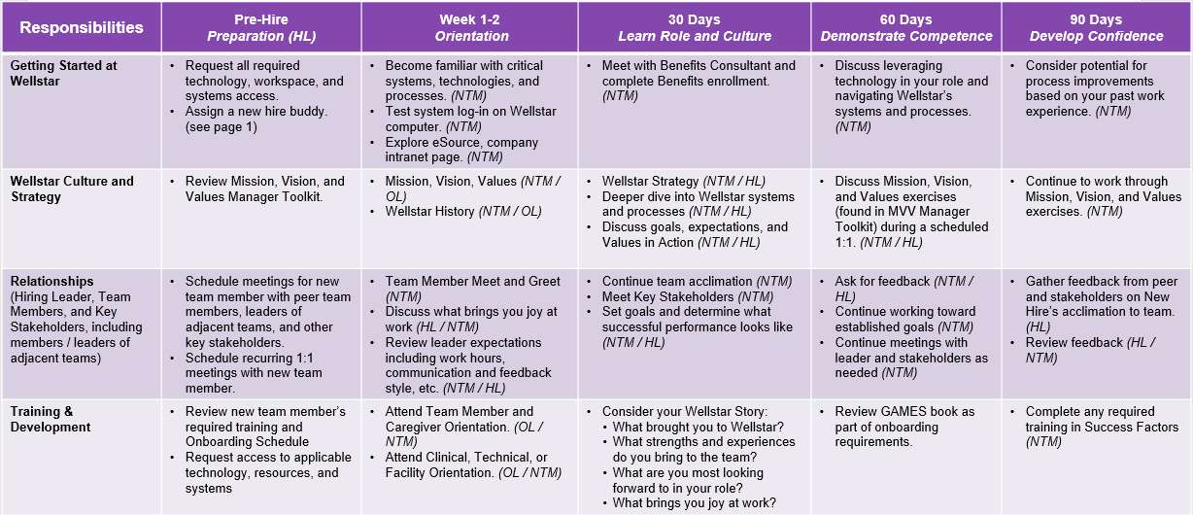

**Abbreviations:** Hiring Leader (HL), New Team Member (NTM), HR Leader (HR), Organizational Learning (OL)

**Important Contacts**

Set up for technology, resources, and systems access, as applicable:

* Employee ID
* Workspace and keys
* Computer
* Cell Phone
* Business Cards
* VPN Access
* Relevant System Access
  + Lawson
  + Strata
  + SuccessFactors
  + Dashboards (Distribution Lists)
* Shared Drives
* Sharepoint sites
  + Etc...
* Facility Tour
* Conference Room Locations
* Local contacts, Security, EVS, etc.
* Printing
* Mailbox
* Office supplies
* Brand Resource Center
* ______________________________________
* ______________________________________
* ______________________________________
* ______________________________________
* _____________________________________

1

|  |  |
| --- | --- |
| Hiring Leader | |
| First Last | Title, Contact Information |
|  |  |
| Team Members | |
| First Last | Title, Contact Information |
| First Last | Title, Contact Information |
| First Last | Title, Contact Information |
| First Last | Title, Contact Information |
|  |  |
| Key Stakeholders | |
| First Last | Title, Contact Information |
| First Last | Title, Contact Information |
| First Last | Title, Contact Information |
| First Last | Title, Contact Information |
|  |  |
| Support Resources | |
| IT Service Desk | 470-956-6000 |
| Local Security | 470-956-XXXX |
| Department Admin | 470-956-XXXX |
|  |  |
| Your HR Contacts | |
| Your HR Partner | Contact Information |
| Benefits | Contact Information |

**The Essentials Checklist**

Direct Leader (DL), New Hire (NH), HR Leader (HR)

**Detailed Onboarding Schedule**

**New Hire Goals**

* Learn about Wellstar’s culture and strategy.
* Build partnerships with your colleagues and stakeholders.
* Become familiar with your role and what success looks like

**Tips for Hiring Leader**

* Review Strategic Onboarding Plan, Department Checklist and Individual Competency Assessments and add key dates, topics to review, contacts, etc. in this template.

|  |  |
| --- | --- |
| **Week** | **Meetings** |
| Week 1  X/XX - X/XX | Day 1: New Employee Orientation  Day 2:  Day 3:  Day 4:  Day 5:  Schedule Leader and Onboarding Buddy check ins during this week - may be at begin/end of shift as appropriate based on orientation schedule |
| Week 2  X/XX - X/XX | Day 1:  Day 2:  Day 3:  Day 4:  Day 5:  Check-in with Leader: |
| Week 3  X/XX - X/XX | Day 1:  Day 2:  Day 3:  Day 4:  Day 5:  Check-in with Leader: |
| Week 4  X/XX - X/XX | Day 1:  Day 2:  Day 3:  Day 4:  Day 5:  **30-Day Check-in with Leader:** |
| Week 5-8  X/XX - X/XX | Focus on *Demonstrate Competence* – Wellstar Culture and Strategy, Relationships, Training and Development (Add specific tasks)  **60-Day Check-in with Leader:** |
| Weeks 9-12  X/XX - X/XX | Focus on *Develop Confidence* – Wellstar Culture and Strategy, Relationships, Training and Development (Add specific tasks)  **90-Day Check-in with Leader:** |

**Internal Meetings -** Recurring Team, Governance, Project, Committees, etc.

|  |  |  |  |  |
| --- | --- | --- | --- | --- |
| **Meeting** | **Attendees** | **Date of Meeting** | **Meeting Leader** | **Notes** |
| **Team Meeting** |  |  |  |  |
| **Daily Huddles** |  |  |  |  |
| **Manager 1:1s** |  |  |  |  |
| **Quarterly Town Halls** |  |  |  |  |